Searching for the latest book club books? Look for NEW! directly before the book title.

2024 EVERETT PUBLIC LIBRARY BOOK CLUB COLLECTION
FICTION
1984 | George Orwell |292 pages. Portrays life in a future time when a totalitarian government watches over all citizens and directs all activities. Orwell’s novel remains an urgent call for the person willing to speak truth to power.
ALL SYSTEMS RED | Martha Wells | 152 pages. "As a heartless killing machine, I was a terrible failure," confesses the AI narrator of this fast-paced SF adventure. After hacking its own governor module and overriding its programming, security droid "Murderbot" ends up saving lives instead of ending them -- but only because letting all the humans die would interfere with its favorite activity: binge- watching some 35,000 hours worth of entertainment media. This tale’s snarky protagonist & suspenseful, action-packed plot will have readers eagerly anticipating future episodes of the Murderbot Diaries.
AN AMERICAN MARRIAGE| Tayari Jones | 308 pages. Married for just over a year, Roy and Celestial are still navigating their new dynamic as husband & wife. Then their lives are forever altered when they travel to Roy’s small Louisiana hometown for a visit, & Roy is falsely accused of a harrowing crime & sentenced to 12 yrs in prison. An Everett Reads book.
ANXIOUS PEOPLE | Fredrik Backman | 341 pages. Taken hostage by a failed bank robber while attending an open house, eight anxiety-prone strangers— including a redemption-seeking bank director, two couples who would fix their marriages and a plucky octogenarian—discover their unexpected common traits.
ANYTHING IS POSSIBLE | Elizabeth Strout | 254 pages. Lucy is long gone from Amgash, Illinois, but her absence looms large; now that she's a well-known author, the fact that her desperately poor family was despised & outcast has become an uncomfortable memory for the locals, including her damaged brother and sister.
ASK AGAIN, YES |Mary Beth Keane | 400 pages. Neighboring families in a New York commuter suburb are entwined, root and branch, through work, their children, and a tragedy of profound consequence. A solidly satisfying, immersive read.
BENEATH A SCARLET SKY | Mark Sullivan | 524 pages. A teenage boy in 1940s Italy becomes part of an underground railroad that helps Jews escape through the Alps but is forced by his parents to enlist as a German soldier for his own protection, where he becomes a spy for the Allies. Based on a true story of a forgotten hero, Beneath a Scarlet Sky is the trium- phant, epic tale of a young man’s incredible courage and resilience during one of history’s darkest hours.
BLUEBIRD, BLUEBIRD |Attica Locke | 307 pages. What appears at first to be a double hate crime in a tiny Texas town turns out to be much more complicated— and more painful—than it seems. Locke deserves a career breakthrough for this deftly plotted whodunit whose writing pulses throughout with a raw, blues-inflected lyricism.
BOOK LOVERS |Emily Henry | 384 pages. Agreeing to a holiday escape to the country, literary agent Nora keeps running into a bookish, hardheaded, arrogant editor she knows from Manhattan, and wishes she didn't, even as she discovers they have more in common than previously thought.
THE BOOK THAT MATTERS MOST | Ann Hood | 386 pages. A mother and daughter seek balance in their broken lives while books provide them with comfort, clarity, and clues to a mystery. Readers will be carried away with the hope that these lovely and damaged players can find their own happy ending.
THE BOOK WOMAN OF TROUBLESOME CREEK |Kim Michele Richardson | 308 pages. One of Kentucky’s last living “Blue People,” 19-year-old Cussy Mary Carter works as a traveling librarian in 1930s Appalachia. A unique story about Appalachia and the healing power of the written word.
THE BOY, THE MOLE, THE FOX AND THE HORSE |Charlie Mackesy | 128 pages. A boy becomes friends with a mole. They talk about life’s pleasures & their fears, and along the way they run into a fox who doesn’t talk much but feels relieved by the company, and the three friends eventually meet a horse who follows them in their existential adventure.
COMMONWEALTH | Ann Patchett | 336 pages. A five-decade saga tracing the impact of an act of infidelity on the parents and children of two Southern California families traces their shared summers in Virginia and the disillusionment that shapes their lasting bond.
THE DAUGHTER OF DOCTOR MOREAU | Silvia Moreno-Garcia | 306 pages. In this thorny riff on The Island of Doctor Moreau, bestseller Moreno-Garcia interweaves several threads in 19th-century Mexico.
DEAR COMMITTEE MEMBERS | Julie Schumacher | 180 pages. Enduring budget cuts & the favoritism of other departments at his small liberal arts college, lit professor Jason Fitger despairs of his writing ambitions & imposed role in a star pupil's would-be opus while writing wryly comic, passive-aggressive letters to students & colleagues.
Pulitzer Prize Winner | DEMON COPPERHEAD | Barbara Kingsolver | 548 pages. Inspired by David Copperfield, Kingsolver crafts a 21st-century coming- of-age story set in America’s hard-pressed rural South. Offering a deeply evocative story, Kingsolver introduces Demon Copperhead, 11, the quick-witted son and budding cartoonist of a troubled young mother and a stepfather.
THE DISPLACEMENTS | Bruce Holsinger | 432 pages. When a hurricane upends everything they have taken for granted, the privileged Larson-Hall family find themselves displaced to a FEMA megashelter where their new community includes an insurance- agent-turned-drug dealer, a group of vulnerable children, and a dedicated relief worker trying to keep the peace.
THE DREAMERS | Karen Thompson Walker | 317 pages. Presents the provocative, hypnotic story of a student in an isolated Southern California college town who witnesses a strange sleeping illness that subjects patients to life-altering, heightened dreams. What is the nature of an epidemic? What is the nature of consciousness? What mix of loyalty and love binds individuals together?
DREAMERS OF THE DAY | Mary Doria Russell | 253 pages. An Ohio teacher travels to Egypt during the 1921 Cairo Peace Conference meeting Winston Churchill, Lawrence of Arabia and Gertrude Bell. An inspired fictional study of political folly.
ELEANOR OLIPHANT IS COMPLETELY FINE | Gail Honeyman | 325 pages. Witty, charming, and heartwarming, this novel is a remarkable debut about a singular woman. Readers will cheer Eleanor as she confronts her dark past & turns to a brighter future. Feel good without feeling smarmy.
ELLA MINNOW PEA: A NOVEL IN LETTERS | Mark Dunn|220 pages. A mostly lighthearted tweaking of literary sensibilities, playwright Dunn’s first novel gets good mileage from a simple notion: People can carry hero worship way too far.
THE ESSEX SERPENT | Sarah Perry |418 pages. The unlikely friendship between a canny widow and a scholarly vicar sets the stage for this sweeping 19th- century saga of competing belief systems. Stuffed with smarts and storytelling sorcery, this is a work of astonishing breadth and brilliance.
FLIGHT BEHAVIOR |Barbara Kingsolver | 436 pages. Tired of living on a failing farm and suffering oppressive poverty, bored housewife Dellarobia Turnbow, on the way to meet a potential lover, is detoured by a miraculous event on the Appalachian Mountains that ignites a media and religious firestorm, changing her life forever.
FLYING SOLO |Linda Holmes | 308 pages. Returning to her Maine hometown to handle her great aunt's estate, Laurie investigates a love letter & a mysterious wooden duck she found at the bottom of a cedar chest and is swept up in a journey of self-discovery.
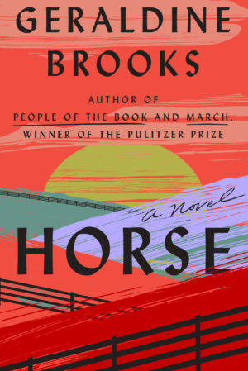
THE FOUNDLING |Ann Leary | 320 pages. In 1927, when 18-year-old Mary Engle, while working at an institution for mentally disabled women, learns that a girl from her childhood orphanage is an inmate, who begs Mary to help her escape, forcing Mary to make a terrible choice with life-altering consequences.
A GENTLEMAN IN MOSCOW | Amor Towles | 462 pages. Sentenced to house arrest in Moscow's Metropol Hotel by a Bolshevik tribunal for writing a poem deemed to encourage revolt, Count Alexander Rostov nonetheless lives the fullest of lives, discovering the depths of his humanity.
GIRL IN DISGUISE | Greer Macallister |319 pages. Going undercover to infiltrate the seedy side of mid-nineteenth-century Chicago, Kate Warne, the first female Pinkerton detective, assumes a range of sophisticated identities to track down evildoers and bring them to justice.
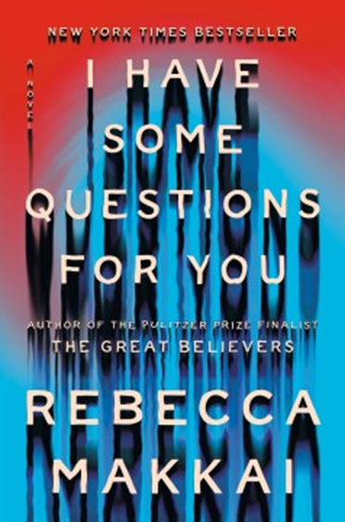
GIRL WAITS WITH GUN |Amy Stewart | 410 pages. Living in virtual isolation years after the revelation of a painful family secret, Constance Kopp is terrorized by a belligerent silk factory owner and fights back in ways outside the norm for early twentieth-century women.
Booker Prize | GIRL, WOMAN, OTHER |Bernardine Evaristo | 452 pages. This polyphonic novel of modern Britain and womanhood. From one of Britain’s most celebrated writers of color, a magnificent portrayal of the intersections of identity. The novel follows several generations of an interconnected group of mainly Black British women.
THE GOOD EARTH | Pearl Buck | 357 pages. A Chinese peasant overcomes the forces of nature and the frailties of human nature to become a wealthy landowner.
THE HANDMAID’S TALE | Margaret Atwood | 309 pages. Offred, a Handmaid, describes life in what was once the United States, now the Republic of Gilead, a shockingly repressive and intolerant monotheocracy, in a satirical tour de force set in the near future.
NEW! | HORSE | Geraldine Brooks | 401 pages. A fascinating saga based on the true story of a famous 19th-century racehorse. A long-lost painting sets in motion a plot intertwining the odyssey of the famed thoroughbred and his trainer with the 21st-century rediscovery of the horse’s portrait.

THE HOUSE IN THE CERULEAN SEA | TJ Klune | 398 pages. A tightly wound caseworker is pushed out of his comfort zone when he's sent to observe a remote orphanage for magical children. Praised for its warmth and messages of love and acceptance, this is a breezy and fun contemporary fantasy.
I FOUND YOU | Lisa Jewell | 344 pages. Three lonely people meet when their lives are in upheaval and learn they are also connected by a haunting 20-year-old mystery. The novel's central question: how much does knowing a person in the present count for? Dark and moody, this is a mystery with substance.
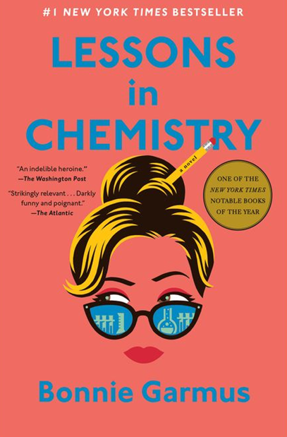
NEW! | I HAVE SOME QUESTIONS FOR YOU | Rebecca Makkai | 448 pages. In the riveting new novel from the author of the Pulitzer Prize and National Book Award Finalist The Great Believers, a woman must reckon with her past when new details surface about a tragedy at her elite New England boarding school. Well plotted, well written, and well designed to make its points.
INLAND | Tea Obreht | 374 pages. An unexpected relationship between a frontierswoman riding out the Arizona Territory drought of 1893 and a former outlaw, who has the ability to see ghosts, inspires an epic journey across the West.
THE INVENTION OF WINGS | Sue Monk Kidd | 373 pages. Kidd hits her stride and avoids sentimental revisionism with this historical novel about the relationship between a slave and the daughter of slave owners in antebellum Charleston.
LAKE SUCCESS | Gary Shteyngart | 338 pages. A hedge fund manager on the skids takes a cross-country Greyhound bus trip to reconnect with his college girlfriend, leaving his wife to deal with their autistic 3-year-old. Smart, relevant, fundamentally warm-hearted, hilarious, and it has a great ending.
THE LAST WHITE MAN | Mohsin Hamid | 180 pages. Overnight, Anders's skin has turned dark, a secret he initially shares only with new lover Oona. But soon people everywhere are being transformed, raising tough questions. How can you recognize friends and family? Can you love them as you once did, changed as they are? And is the old social order, with its attendant prejudices, about to be tossed out the window? Sharp-edged political/fantastical allegory from two-time Booker Prize finalist Hamid.
Pen/Bellwether Prize for Fiction |THE LEAVERS| Lisa Ko | 350 pages. Ko’s quietly sensational debut novel about migration, deportation, and contested citizenship, is the story of a boy abandoned in the U.S., his undocumented Chinese mother, and the dark, devastating truth behind it.

NEW! | LESSONS IN CHEMISTRY | Bonnie Garmus | 400 pages. In the early 1960s, chemist and single mother Elizabeth Zott, the reluctant star of America’s most beloved cooking show due to her revolutionary skills in the kitchen, uses this opportunity to dare women to change the status quo.

LIFE AND OTHER INCONVENIENCES | Kristan Higgins | 428 pages. A blue-blood grandmother and her black sheep granddaughter discover they are truly two sides of the same coin.
THE LIGHTKEEPER’S DAUGHTERS | Jean E. Pendziwol | 307 pages. A decades-old mystery is revisited as an elderly woman shares the story of her childhood with a troubled teen. This haunting tale of nostalgia and lost chances is full of last-minute surprises.
LILLIAN BOXFISH TAKES A WALK | Kathleen Rooney |284 pages. Embarking on a walk across Manhattan on New Year's Eve in 1984, eighty-five-year-old Lillian Boxfish recalls her long and eventful life, which included a brief reign as the highest-paid advertising woman in America, whose career was cut short by marriage and loss. Rooney’s lively, fictionalized version of Margaret Fishback--poet and writer of clever, innovative ad copy--offers plenty of charm and occasional poignance.
THE LINCOLN HIGHWAY | Amor Towles| 576 pages. This magnificent comic road novel follows 18-year-old Emmett Watson, newly released from a work farm in 1950s Kansas, and little brother Billy, following the death of their father and the foreclosure of their Nebraska farm. A remarkable blend of sweetness and doom, Towles’ novel is packed with revelations about the American myth, the art of storytelling, and the unrelenting pull of history. An exhilarating ride through Americana.

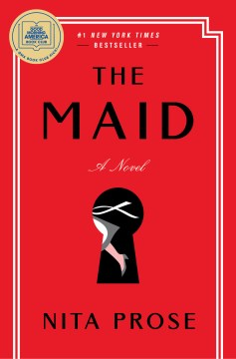
NEW! | THE MAID | Nita Prose | 304 pages. Molly Gray, an eccentric young woman who's obsessed with cleaning but doesn't quite have the same ability to navigate social cues as those around her, loves working as a maid at the Regency Grand Hotel. The shocking murder of a public figure at this high-end hotel has everyone guessing who the culprit might be--with Molly being the prime suspect.
A MAN CALLED OVE | Fredrik Backman | 337 pages. A curmudgeon hides beneath a cranky and short- tempered exterior a terrible personal loss while clashing with new neighbors, a boisterous family whose chattiness and habits lead to unexpected friendship. This debut was originally published in Sweden.
MIRACLE CREEK | Angie Kim | 355 pages. A literary courtroom thriller and classic whodunit about a mother accused of murdering her eight-year-old autistic son. During an alternative medical treatment, an explosion kills two people and injures six others. The fire that caused the explosion was set deliberately, and readers follow along as Kim weaves moments of drama set in the present with flashbacks to the past.
MY GRANDMOTHER ASKED ME TO TELL YOU SHE’S SORRY | Fredrik Backman | 372 pages. Precocious seven-year-old Elsa and her feisty grandmother are inseparable. When Granny passes away, Elsa is sent on a scavenger hunt involving letters of apology from Granny to various people she wronged throughout her life.

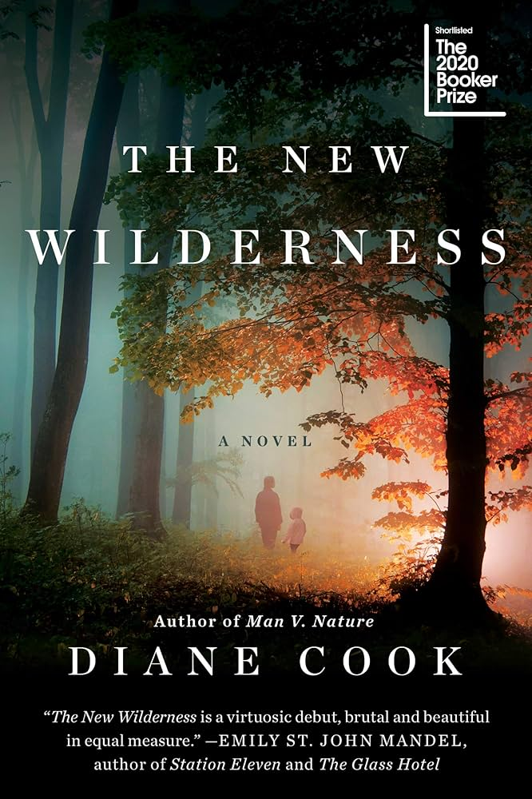
NEW! | Booker Prize | THE NEW WILDERNESS | Diane Cook | 398 pages. A mother desperate to save her dying daughter in a world ravaged by climate change joins a hunter- gatherer initiative to test humanity's capacity to survive in the wilderness without destroying it. A 2024 Everett Reads book.
OLIVE, AGAIN | Elizabeth Strout | 289 pages. This collection of 13 interconnected stories that take place in or near the fictional town of Crosby, Maine follows Olive through her seventies and eighties after the death of her first husband. Olive, Again is the sequel to Olive Kitteridge, which won the Pulitzer Prize. Olive Kitteridge was made into a limited television series by HBO, starring Frances McDormand, in 2014.
ONE ITALIAN SUMMER | Rebecca Serle | 253 pages. A 30-year-old married woman from Los Angeles, finding herself adrift after her mother’s death, travels to Italy on a long-awaited vacation they had planned to take together. An unconventional love story that embraces people’s flaws and selfishness as part of what makes them human.
OUR COUNTRY FRIENDS | Gary Shteyngart | 289 pages. When a group of old friends & friends-of-friends gathers in a country house to wait out the pandemic, they end up spending six months in isolation during which old betrayals emerge, forcing each character to reevaluate whom they love and what matters most.
THE NIGHTINGALE | Kristin Hannah | 448 pages. An absorbing homage to the extraordinary courage and endurance of Frenchwomen during World War II. Reunited when the elder's husband is sent to fight in World War II, French sisters Vianne and Isabelle find their bond as well as their respective beliefs tested by a world that changes in horrific ways.
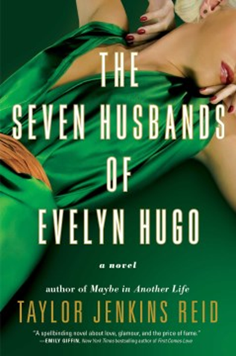
THE PARAGON HOTEL | Lyndsay Faye | 422 pages. Fleeing to 1921 Oregon, Alice takes refuge in the city's only black hotel and helps new friends search for a missing child, hide from KKK violence, and navigate painful secrets.
THE PERFECT NANNY | Leila Slimani | 228 pages. This novel about a murderous nanny, Moroccan author Slimani's American debut, was awarded the 2016 Prix Goncourt. The why of this horrific crime remains unfathomable, rendering it even more frightening. It is a compulsive, riveting, bravely observed exploration of power, class, race, domesticity, and motherhood.
National Book Award | THE RABBIT HUTCH | Tess Gunty | 402 pages. In her astonishing debut novel, Gunty expertly weaves together a chorus of stories around Blandine and other forgotten souls of the Rabbit Hutch. Through shifting perspectives, Gunty touches on mental illness, the limits of capitalism, trauma, loneliness, and the necessity of human connection. As smart as it is entertaining.
THE RAILWAYMAN’S WIFE |Ashley Hay | 265 pages. Amidst the strange, silent aftermath of World War II, a widow, a poet, and a doctor search for peace and fresh beginnings in this absorbing and uplifting read.
THE REVISED FUNDAMENTALS OF CAREGIVING | Jonathan Evison | 278 pages. The book centers on a lonely and depressed caregiver who goes on a road trip with his disabled teenage charge, and together they learn about life, friendship, and hope. Adapted into a major motion picture. Evison resides in the Pacific NW.
THE ROSIE PROJECT | Graeme Simsion | 295 pages. A brilliant, but emotionally challenged geneticist develops a questionnaire to screen potential mates and finds love instead.
National Book Award |THE ROUND HOUSE | Louise Erdrich | 317 pages. An American Indian family faces the ramifications of a vicious crime.

NEW! | THE SEVEN HUSBANDS OF EVELYN HUGO | Taylor Jenkins Reid | 383 pages. When an aging and reclusive Hollywood icon selects an unknown magazine reporter to write her life story, the baffled journalist forges deep ties with the actress during a complicated interview process that exposes their tragic common history. Reid's heroine reveals her darkest secrets as if she were wiping off makeup at the end of the night—a celebration of human frailty that speaks to the Marilyn Monroe and Elizabeth Taylor in us all.
SMALL WORLD | Jonathan Evison | 466 pages. In this epic historical novel Evison braids together story lines from different time periods — in this case present-day travelers on a train and their ancestors more than a century before. Brought together by the history they share, four families on a journey spanning from the 1850s to 2019 tell their stories against such iconic backdrops as the California gold rush and the development of the Continental Railroad. Evison resides in the Pacific Northwest.
SOLD ON A MONDAY | Kristina McMorris | 343 pages. In Depression-era Pennsylvania, a romance develops between two lonely people fighting for the rights of an impoverished family. A tender love story enriches a complex plot, giving readers a story with grit, substance, and rich historical detail. Inspired by an actual newspaper photograph that stunned the nation.
THE SOULMATE EQUATION |Christina Lauren | 360 pages. This entertaining novel follows single mom & data & statistics wizard Jess Davis as she, using a revo- lutionary new scientific dating app, is matched with the app’s arrogant creator who is not what he seems.
SOUTHERNMOST | Silas House| 352 pages. A road novel about a father and son that mixes warmth, empathy, tragedy, and hope. A brave tale of power and peace that comes from heeding the courage of one's convictions. The suspenseful climax will leave readers floored. Includes brilliant descriptions of summer days in languid Key West.
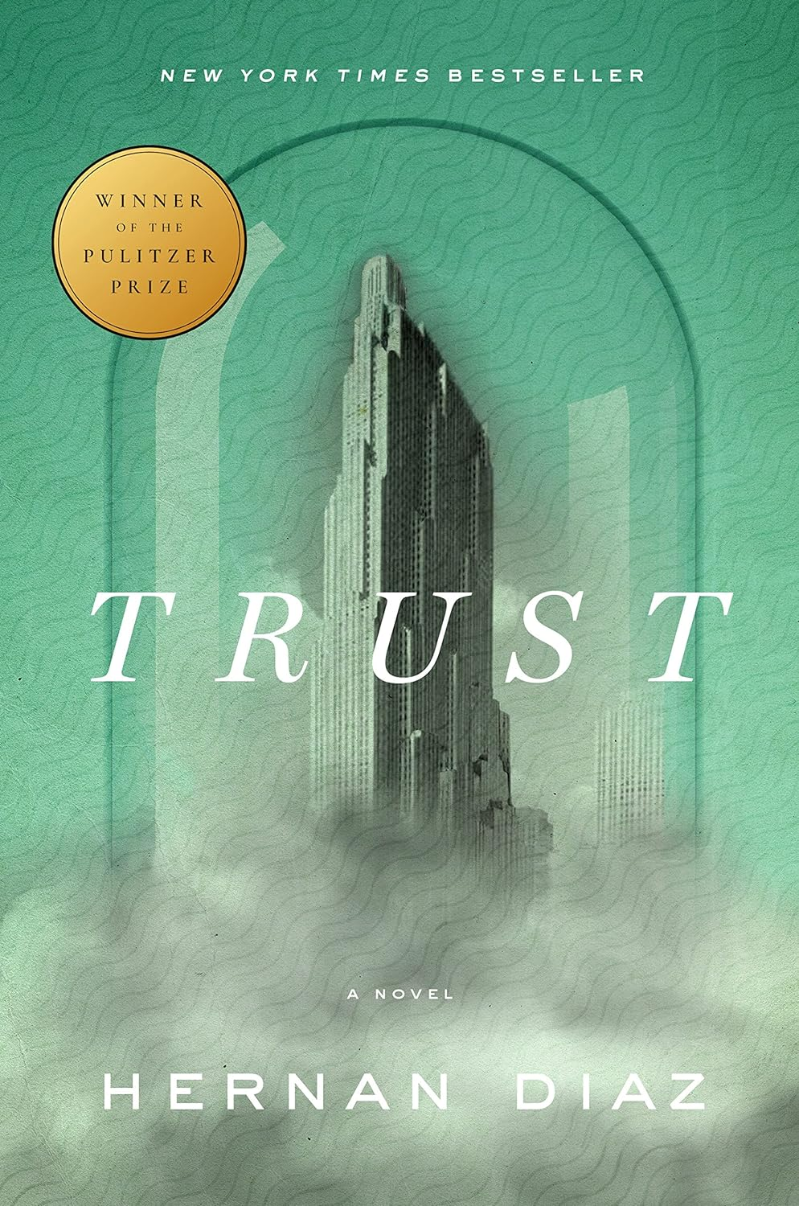
STATION ELEVEN |Emily St. John Mandel |320 pages. Survivors and victims of a pandemic populate this ambitious take on a post-apocalyptic world where some strive to preserve art, culture, and kindness.
THE STORIED LIFE OF A.J. FIKRY | Gabrielle Zevin | 270 pages. If you like books that make you laugh and cry at the same time, check out this tale about a cranky, isolated bookstore owner who receives a surprise and life-changing package to help him restart his life.
THE STORYTELLER | Jodi Picoult | 460 pages. Becoming friends with Josef Weber, an old man who's particularly loved in her community, Sage Singer is shocked when one day he asks her to kill him and reveals why he deserves to die, causing her to question her beliefs--and to wonder if his request would be murder or justice.
A TALE FOR THE TIME BEING | Ruth Ozaki | 403 pages. A novelist on a remote island in the Pacific is linked to a bullied and depressed Tokyo teenager after discovering a Hello Kitty lunchbox that washed ashore.
THERE THERE | Tommy Orange | 294 pages. A debut novel which grapples with the complex history of Native Americans; with an inheritance of profound spirituality; and with a plague of addiction, abuse, and suicide, follows 12 characters, each of whom has private reasons for traveling to the Big Oakland Powwow.
THE THURSDAY MURDER CLUB |Richard Osman |355 pages. Meeting weekly in their retirement village's Jigsaw Room to exchange theories about unsolved crimes, four savvy septuagenarians propose a daring but unorthodox plan to help a woman rookie cop solve her first big murder case.
THE TRAVELLING CAT CHRONICLES | Hiro Arikawa | 277 pages. A wise and witty cat and his gentle master share an indomitable spirit that helps them survive and thrive in any situation in this Japanese bestseller. Gentle, soft-spoken, and full of wisdom.
NEW! | Pulitzer Prize | TRUST | Hernan Diaz | 417 pages. Told from the perspective of one woman bent on disentangling fact from fiction, this unrivaled novel about money, power, intimacy, and perception is centered around the mystery of how the Rask family acquired their immense fortune in 1920s-1930's New York City. A tale of wealth, love, and madness told in four distinct but connected narratives. A clever and affecting high-concept novel of high finance.
National Book Award | THE UNDERGROUND RAILROAD | Colson Whitehead| 306 pages. After Cora, a pre-Civil War Georgia slave, escapes with another slave, Caesar, they seek the help of the Underground Railroad as they flee from state to state & try to evade a slave catcher who is determined to return them.
THE UNLIKELY PILGRIMAGE OF HAROLD FRY | Rachel Joyce | 320 pages. Retired Harold Fry is convinced he must travel to deliver a letter to an old love to save her. He meets various characters along the way and reminisces about the events of his past and people he has known, as he tries to find peace & acceptance.
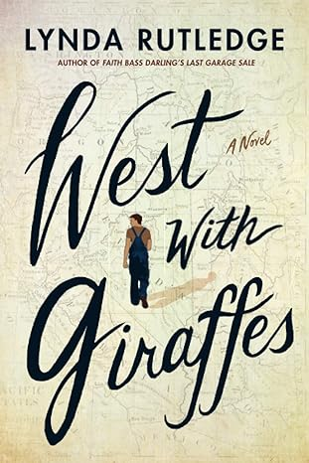
NEW! | WEST WITH GIRAFFES | Lynda Rutledge | 372 pages. Inspired by true events, this part adventure, part historical saga and part coming-of-age love story follows Woodrow Wilson Nickel as he recalls his journey in 1938 to deliver Southern California’s first giraffes to the San Diego Zoo.
WHERE THE CRAWDADS SING | Delia Owens | 370 pages. Viewed with suspicion in the aftermath of a tragedy, a beautiful hermit who has survived for years in a marsh becomes targeted by unthinkable forces.
THE WHISTLING SEASON | Ivan Doig | 345 pages. This story captures the life of early western settlers in Montana. In the present day, Paul, the Montana state superintendent of schools, has been tasked with deciding the fate of the state's last rural schools. As he struggles with the decisions he must make, Paul recalls his childhood and the one-room schoolhouse he attended in Montana in the fall of 1909.
WINTER SISTERS | Robin Oliveira | 416 pages. When the two young daughters of friends killed in a late-19th-century storm vanish without a trace, a former Civil War surgeon launches a determined rescue effort that is challenged by a community that believes there is no hope and a violin-student niece who returns home from Paris with a secret agenda.
WINTERING | Peter Geye | 300 pages. After their elderly, demented patriarch runs into the wilderness of northern Minnesota to reenact a similar adventure 60 years earlier, a father and son bond through several months of self-exile in the remote borderlands of northern Minnesota.

NON-FICTION

AMERICAN NATIONS: A HISTORY OF THE ELEVEN RIVAL REGIONAL CULTURES OF NORTH AMERICA | Colin Woodard | 322 pages. A history of North America's eleven rival cultural regions challenges popular perceptions about the red state-blue state conflict, tracing lingering tensions stemming from disparate international values that have shaped every major event in history.
THE ART THIEF: A TRUE STORY OF LOVE, CRIME, AND A DANGEROUS OBSESSION | Michael Finkel | 221 pages. Finkel presents a roller-coaster read of hubris and romance, contradiction, and despair. Over eight years and more than 200 heists, Stéphane Breitwieser (b. 1971) made off with almost $2 billion worth of loot. Finkel follows the string of Breitwieser's thefts across Europe. His crimes are particularly fascinating because Breitwieser kept all his booty and kept it all in one room where he could admire it.


NEW! | THE BOYS IN THE BOAT: NINE AMERICANS AND THEIR EPIC QUEST FOR GOLD AT THE 1936 BERLIN OLYMPICS | Daniel James Brown | 334 pages. The long, passionate journey of the University of Washington rowing team to the 1936 Berlin Olympics. A touching portrayal of rowing legends.
BLUE NIGHTS | Joan Didion | 188 pages. Didion delivers a second masterpiece on grief (the first being The Year of Magical Thinking), considering both her daughter's death and her inevitable own. The book feels like an epitaph for both, as she considers how much aging has demolished her preconceptions about growing old. A slim, somber classic.
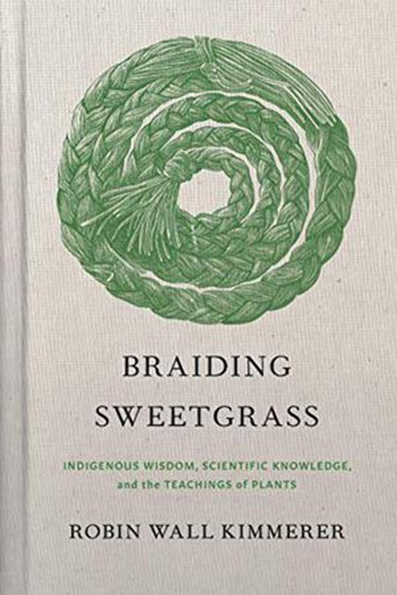
NEW! | BRAIDING SWEETGRASS: INDIGENOUS WISDOM, SCIENTIFIC KNOWLEDGE AND THE TEACHINGS OF PLANTS | Robin Wall Kimmerer | 382 pages. Wisdom about the natural world delivered by an able writer who is both Indigenous and an academic scientist. A smart, subtle overlay of different systems of thought that together teach us to be better citizens of Earth.

CODE GIRLS: THE UNTOLD STORY OF THE AMERICAN WOMEN CODE BREAKERS OF WORLD WAR II | Liza Mundy | 416 pages. An untold history of the American women who served as code breakers during WWII. A well-researched, compellingly written, crucial addition to the literature of American involvement in WWII.
CONSTRUCTING A NERVOUS SYSTEM | Margo Jefferson | 256 pages. The award-winning critic and memoirist has lived in the thrall of a cast of others--her parents and maternal grandmother, jazz luminaries, writers, artists, athletes, and stars, and she brings these figures to life in a new memoir.
CRYING IN H MART | Michelle Zauner | 320 pages. The Japanese Breakfast indie pop star presents a full-length account of her viral New Yorker essay to share poignant reflections on her experiences of growing up Korean American, becoming a professional musician and caring for her terminally ill mother.
EDUCATED: A MEMOIR | Tara Westover | 334 pages. A Cambridge Univ doctorate debuts with a wrenching account of her childhood & youth in a strict Mormon family in a remote region of Idaho. An astonishing debut of deprivation, confusion, survival, & success.
THE FOUNDING FATHERS: THE REVOLUTIONARY GENERATION, NATURE, AND THE SHAPING OF THE AMERICAN NATION | Andrea Wulf | 349 pages. Reviews the lives of the founding fathers from their perspectives as gardeners, farmers, and plantsmen, revealing how a shared passion for agriculture shaped their beliefs and decisions.
HERO OF THE EMPIRE: THE BOER WAR, A DARING ESCAPE, AND THE MAKING OF WINSTON CHURCHILL | Candice Millard | 318 pages. Millard presents a narrative account of Churchill's lesser-known heroics during the Boer War, describing his daring escape from rebel captors, trek through hundreds of miles with virtually no supplies and eventual return to South Africa to liberate the soldiers captured with him.
HILLBILLY ELEGY: A MEMOIR OF A FAMILY AND CULTURE IN CRISIS | J.D. Vance | 264 pages. In this understated, engaging debut, Vance reflects on his stormy journey from the coal-country Kentucky hollers to the Ivy League-educated elite and the plight of America's angry white working class. "Americans call them hillbillies, rednecks, or white trash," writes Vance, a biotech executive, and National Review contributor. "I call them neighbors, friends, & family."
KILLERS OF THE FLOWER MOON: THE OSAGE MURDERS AND THE BIRTH OF THE FBI |David Gann | 298 pages. Presents a true account of the early twentieth-century murders of dozens of wealthy Osage and law-enforcement officials, citing the contributions and missteps of a fledgling FBI that eventually uncovered one of the most chilling conspiracies in U.S. history. A film based on the book and directed by Martin Scorsese was released in 2023.
THE LIBRARY BOOK | Susan Orlean |319 pages. Through the story of the Los Angeles Central Library, Orlean provides a history of libraries, examining what we stand to lose as the world’s base of knowledge transitions into the digital realm.
LOTS OF CANDLES, PLENTY OF CAKE | Anna Quindlen |182 pages. Bestselling author writes about her life and the lives of women today. She considers marriage, friends, mothers, loss, etc.
NORSE MYTHOLOGY | Neil Gaiman |299 pages. A spectacularly entertaining and elucidating collection of stories. Presents a rendering of the major Norse pan- theon that traces the genesis of the legendary 9 worlds & the exploits of its characters, illuminating the char- acters & natures of iconic figures Odin, Thor, & Loki.
OBSESSIVE GENIUS: THE INNER WORLD OF MARIE CURIE | Barbara Goldsmith |256 pages. Draws on diaries, letters, and family interviews to discuss the lesser-known achievements & scientific insights of the Nobel Prize-winning scientist, documenting how she was compromised by the prejudices of a male-dominated society.
THE OREGON TRAIL: A NEW AMERICAN JOURNEY | Rinker Buck | 432 pages. Road trip, old-school style! Though the Oregon Trail fell out of favor with travelers after the transcontinental railroad was finished in 1869, it's still possible to travel the trail from Missouri to Oregon. More than 100 years after the last known crossing, journalist Rinker Buck, his brother, and his brother's Jack Russell terrier set out in a covered wagon pulled by mules. Along with riveting details about their four-month, 2,000-mile trip, Buck describes the rich history of the trail and the 400,000 pioneers who made the journey before him. Funny & touching.

NEW! | Washington State Book Award | Pacific Northwest Book Award | RED PAINT: THE ANCESTRAL AUTOBIOGRAPHY OF A COAST SALISH PUNK by Sasha LaPointe | 208 pages. A punk-infused memoir by a Coast Salish woman about her connection to her heritage. An engaging, poetic, educative examination of the search for home and personal and cultural identity.

RIVER OF THE GODS: GENIUS, COURAGE, AND BETRAYAL IN THE SEARCH FOR THE SOURCE OF THE NILE | Candice Millard |349 pages. Set against the backdrop of the race to exploit Africa by the colonial powers, a story of courage and adventure brings to life the rivalry between two enemies - a decorated soldier and a young aristocrat/Army officer - as they set out to find the mysterious headwaters of the Nile River.
SEEK YOU: A JOURNEY THROUGH AMERICAN LONELINESS | Kristan Radtke |352 pages. Radtke takes a piercing exploration of loneliness and the ways we attempt to feel closer to one another. She looks at the very real current crisis of loneliness through the lenses of gender, violence, technology, and art.
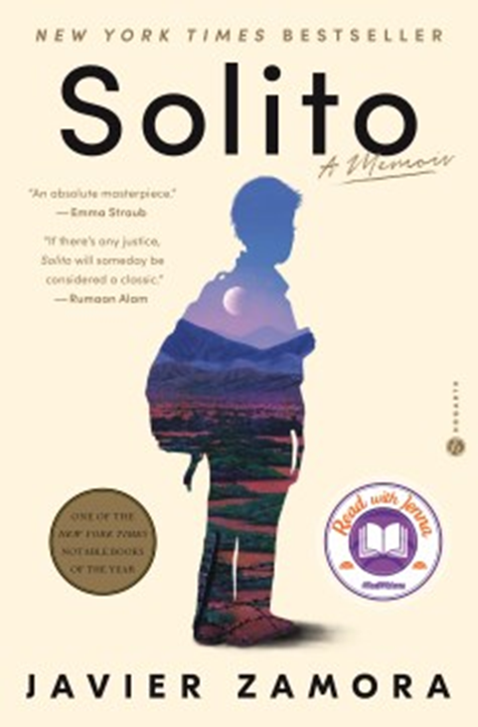
SHORT NIGHTS OF THE SHADOW CATCHER | Timothy Egan | 370 pages. The travels and achievements of photographer Edward Curtis.
NEW! | SOLITO: A MEMOIR | Javier Zamora | 400 pages. A young poet reflects on his 3,000-mile journey from El Salvador to the United States when he was nine years old, during which he was faced with perilous boat trips, relentless desert treks, pointed guns, arrests and deceptions during two life-altering months alongside a group of strangers who became an unexpected family.
THE SOUL OF AN OCTOPUS: A SURPRISING EXPLORATION INTO THE WONDERS OF CONSCIOUSNESS | Sy Montgomery | 247 pages. Naturalist Montgomery chronicles her extraordinary experience bonding with three octopuses housed in the New England Aquarium and the small group of people who became devoted to them. A fascinating glimpse into an alien consciousness.
STARVATION HEIGHTS | Gregg Olsen | 411 pages. True-crime author Olsen tells the story of Dr. Linda Burfield Hazzard, who ran a sanatorium in Seattle where a British heiress died of starvation in 1911. The heiress’ sister was rescued, and subsequent events led to the greedy, evil Hazzard's arrest and trial. This is the even darker side of health fads satirized in T.C. Boyle’s The Road to Wellville.
THE STRANGER IN THE WOODS: THE EXTRAORDINARY STORY OF THE LAST TRUE HERMIT | Michael Finkel | 203 pages. A remarkable tale of survival & solitude-- the true story of a man who lived alone in a tent in the Maine woods, never talking to another person and surviving by stealing supplies from cabins for 27 years.
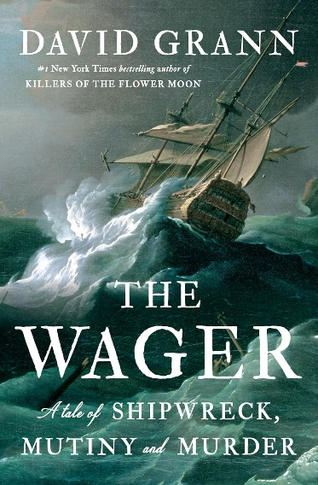
NEW! |THE WAGER: A TALE OF SHIPWRECK, MUTINY AND MURDER | David Grann | 329 pages. The author of Killers of the Flower Moon and The Lost City of Z returns with a rousing story of a maritime scandal. In 1741, the British vessel the Wager, pressed into service during England’s war with Spain, was shipwrecked in a storm off the coast of Patagonia while chasing a silver-laden Spanish galleon. A brisk, absorbing history and a no-brainer for fans of the author’s suspenseful historical thrillers.
THE WARMTH OF OTHER SUNS: THE EPIC STORY OF AMERICA'S GREAT MIGRATION | Isabel Wilkerson | 622 pages. Pulitzer Prize-winning author chronicles one of the great untold stories of American history: the decades-long migration of African American citizens who fled the South in search of a better life.

(3-5-2024)

